**First Django Project**

Objectives:

* Practice setting up a new Django project
* Practice setting up a new Django app
* Practice routing in Django
* Familiarity with views and how to return a response

***Note*** for the assignment, the show, edit, and delete methods will require the use of Route Parameters.

***Bonus*** result:

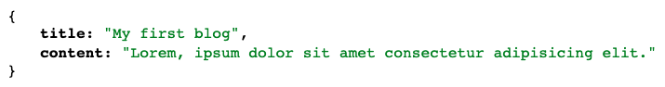

* Top of Form
* Create a new project with a single app
* / - redirects to the "/blogs" route with a method called "root"
* /blogs - display the string "placeholder to later display a list of all blogs" with a method named "index"
* /blogs/new - display the string "placeholder to display a new form to create a new blog" with a method named "new"
* /blogs/create - redirect to the "/" route with a method called "create"
* /blogs/< number > - display the string "placeholder to display blog number: {number}" with a method named "show" (eg. localhost:8000/blogs/15 should display the message: 'placeholder to display blog number 15')
* /blogs/< number >/edit - display the string "placeholder to edit blog {number}" with a method named "edit"
* /blogs/< number >/delete - redirect to the "/blogs" route with a method called "destroy"
* (**Bonus**) /blogs/json - return a JsonResponse with title and content keys.

Bottom of Form